# OAuth2 – API Authentication

The purpose of this document is to explain how to use the OAuth2 authentication endpoint to connect to an instance of the MDCS API.

## Configure the Remote instance

1. Open the Admin Dashboard, and go to User Management.

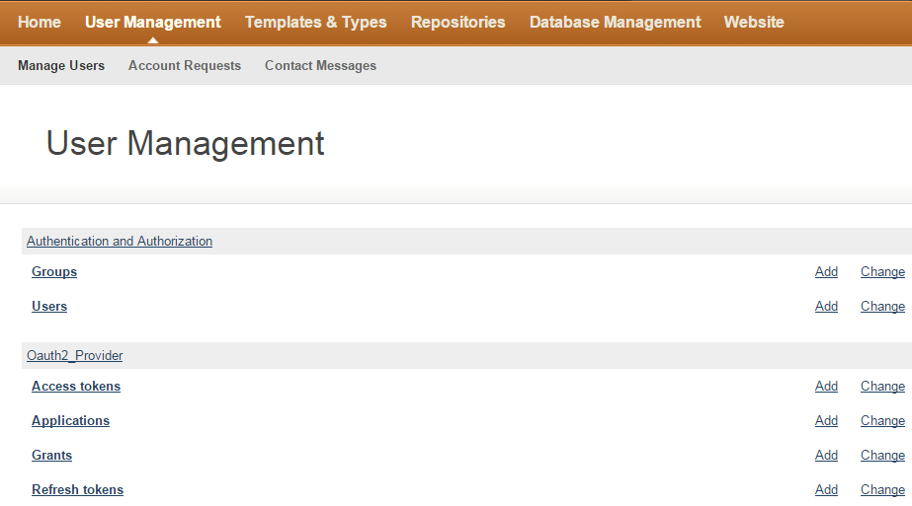

1. Click on the ‘Add’ link, on the Applications line.

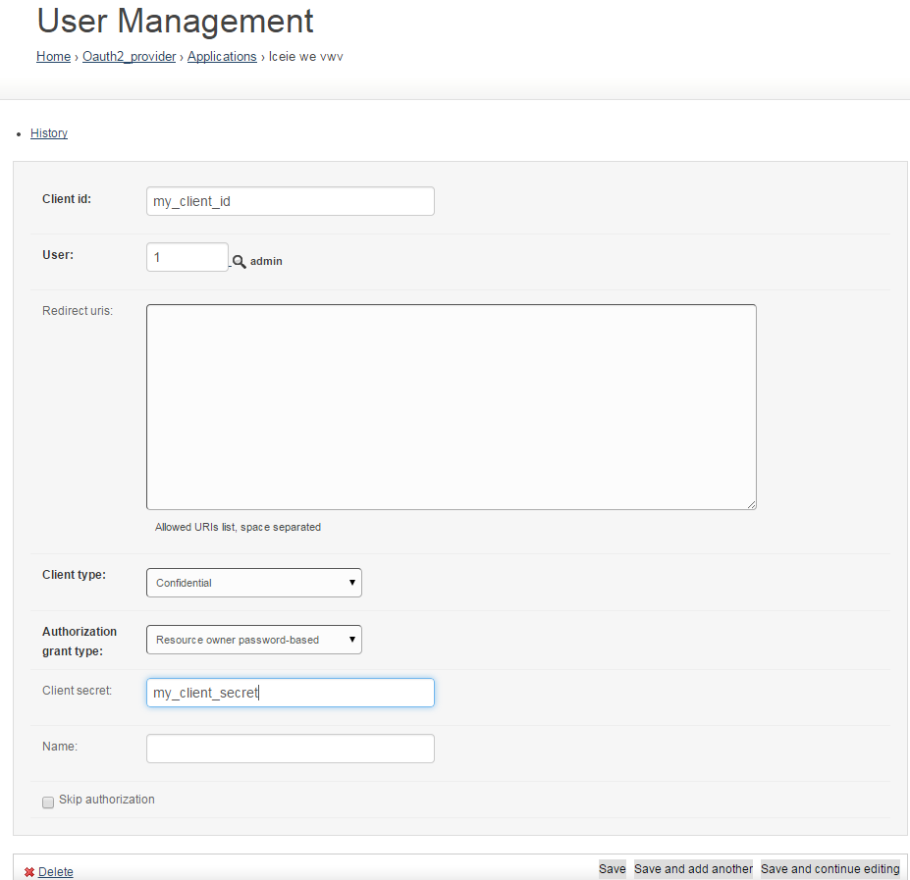

1. Fill the form:

* User: select the user that you will use to access the system remotely. If you are creating a Client for someone else to connect to your instance of the MDCS, you may want to first ask him/her to request an account on the system (or create an account for him/her) and then select this user.
* Client id and Client secret are generated by the MDCS and should be provided to the user that wants to access the system remotely, so he/she can request a token to authenticate on the MDCS. A problem with django-oauth-toolkit package sometimes prevent from using generated values from the system. **So client id and client secret needs to be set manually by the administrator until the problem is not fixed.**
* Client type: select ‘**Confidential**’.
* Authorization grant type: select ‘**Resource owner password-based**’.
* Name: give this client a name. This is the name of the application that will use this client to access the API. It could be the name of a remote instance of the MDCS (e.g. ‘Remote MDCS NIST’), or the name of another program using the MDCS API (e.g. ‘My Script’).

1. Save the Application

## Add a remote instance for federation of queries

1. Open the Admin Dashboard, and go to Repositories.

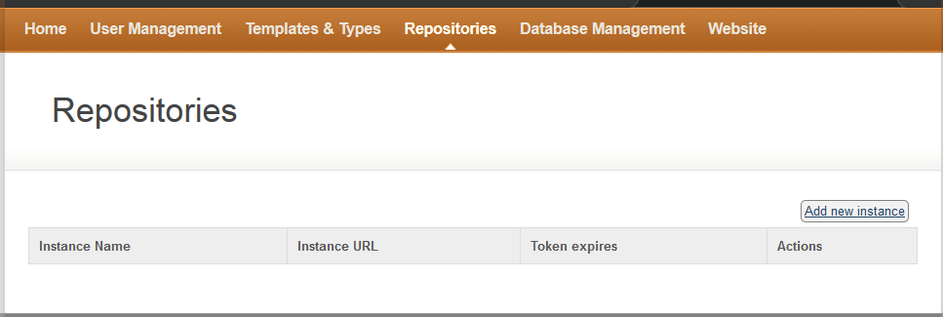

1. Click on ‘Add new Repository’.

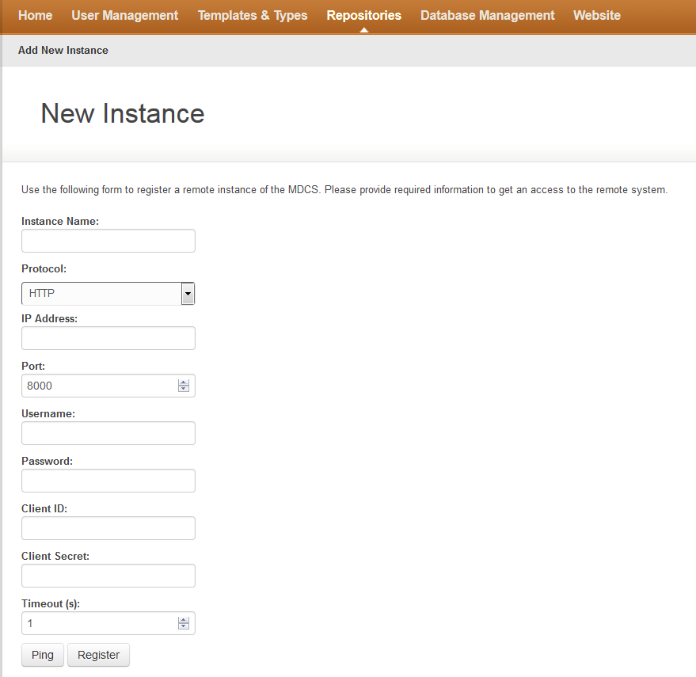

1. Fill the form:

* Instance Name: name of the Remote MDCS instance.
* Protocol: e.g. HTTP, HTTPS
* IP Address: e.g. 1xx.xxx.xxx.xxx
* Port: e.g. 8000
* Username: user on the remote instance
* Password: password of this user on the remote instance
* Client ID: user’s client id on the remote instance
* Client Secret: user’s client secret on the remote instance
* Timeout: time after which the request is interrupted
* Ping: try to reach the remote API using the username and password
* Register: request an access token from the remote isntance